**An overall report on** **The Effects of Metro Rail Constructions in Local Area**

**Name of the Group: Super Six**

Submitted in partial fulfillment of the requirement of the  
Educational Planning (ART 102) course.

**Group members of group:**

|  |  |  |  |  |
| --- | --- | --- | --- | --- |
| Sl. | Name | Id | Section | Program |
| 1 | Adelur Rahman Chowdhury | 22103369 | V | BCSE |
| 2 | Ashraful Islam | 22103370 | V | BCSE |
| 3 | Nabinur Islam Roni | 22103371 | V | BCSE |
| 4 | Prime Biswajit Barua | 22103372 | V | BCSE |
| 5 | Abu Jisan Provat | 22103373 | V | BCSE |
| 6 | Sahidul Islam | 22103374 | V | BCSE |

The date: March_ ,2022

**Letter of Transmittal**

February 27, 2022

Kaniz Kakon

Course instructor

Educational Planning

College of Arts and Sciences

IUBAT —International University of Business Agriculture & Technology

4 Embankment Drive Road, Sector 10,

Uttara Dhaka, 1230.

Subject: Letter of transmittal.

Dear Madam,

We are very pleased to submit our report on “**The Effects of Metro Rail Constructions in Local Area**”

It was a great opportunity for us to work as a reporter on the topic of “**The Effects of Metro Rail Constructions in Local Area**” That you have asked us to prepare on **26 February,2022**. In this report we have to elaborate our knowledge what we learn from our Educational Planning (ART 102) course & give experience about the effects of Metro Rail Constructions in Local Area. We tried to give our maximum effort on preparing this report as best.

Considering the level of hard working, information, processing, and analysis we believe that this report is a complete one. We provide our full concentration to prepare this report. We hope that our study will meet your expectation as well.

Sincerely yours,

Super Six

|  |  |  |  |  |  |
| --- | --- | --- | --- | --- | --- |
| Sl. | Name | Id | Section | Program | Signature |
| 1 | Adelur Rahman Chowdhury | 22103369 | V | BCSE |  |
| 2 | Ashraful Islam | 22103370 | V | BCSE |  |
| 3 | Nabinur Islam Roni | 22103371 | V | BCSE |  |
| 4 | Prime Biswajit Barua | 22103372 | V | BCSE |  |
| 5 | Abu Jisan Provat | 22103373 | V | BCSE |  |
| 6 | Sahidul Islam | 22103374 | V | BCSE |  |

**Acknowledgments**

"We would like to thank our course instructor, Kaniz Kakon for the valuable advice and support she has given us in the writing of this report.

We would also like to thank my teachers, Mrs. Moumitu Tasnim and Mr. Sheikh Rokon for their encouragement and guidance. Thanks also to my typist, Mr. Sakib, for her immaculate job and her suggestions. My deepest thanks go to my or understanding and support."

**Summary / Abstract**

This study was to know the Effects of Metro Rail Constructions in Local Area.

It was requested by Mrs. Kaniz Kakon.

It was requested on 20 February,2022

The investigation was done by Super Six.

The main findings:

* Too much traffic jam
* Dust
* Excess sound of construction
* Narrow street.

It was concluded that this Mega project would bring a remarkable change in the Transportation system of Bangladesh

The recommendations are that this construction should be finished as soon as possible.

**Contents Page**

Section..................................................................Page Number

* 1. [Introduction](http://www2.elc.polyu.edu.hk/CILL/reports.htm#Introduction).............................................................................1
  2. [Literature Review](http://www2.elc.polyu.edu.hk/CILL/reports.htm#Literature Review).....................................................................3
  3. [Methodology](http://www2.elc.polyu.edu.hk/CILL/reports.htm#Methodology)............................................................................5
  4. [Findings](http://www2.elc.polyu.edu.hk/CILL/reports.htm#Findings)...................................................................................7
  5. [Conclusions](http://www2.elc.polyu.edu.hk/CILL/reports.htm#Conclusions)............................................................................14
  6. [Recommendations](http://www2.elc.polyu.edu.hk/CILL/reports.htm#Recommendations)..................................................................16
  7. [Appendices](http://www2.elc.polyu.edu.hk/CILL/reports.htm#Appendices)............................................................................18
  8. [Bibliography](http://www2.elc.polyu.edu.hk/CILL/reports.htm#Bibliography)...........................................................................25

List of Figures

* 1. Bar Chart of Answers to Question 1...........................................8
  2. Pie Chart of Socio-economic Status of the Respondents......9

List of Tables

* 1. Survey Findings by Gender and Age Group........................10

**1.****Introduction**

**Background**This report has been written for the awareness of the effects of Metro Rail Construction.

It was requested by Mrs. Kaniz Kakon

It was requested on 20 February,2022

**Objectives**The objectives of this report are to make a report on the

**Scope**This report examines .... . It does not examine .....because ...... .

**2.****Literature Review**

The area of investigation has been commented on by Channel (1994), Hoey (1993), Halliday (1993) and Lesser (1979), who are in agreement that...

However, they have different opinions on ....

Due to the differences highlighted above, it was decided to investigate ....

**3.****Methodology (also called the 'Method' or 'Procedure')**

**___**respondents, chosen by the method of _____ were surveyed from (start date) to (end date). Of these, ______ were invited for interview on (date).

The statistics were analysed using a _______ test because .........

The significance of the results was __________

**Methodology**

First the projected area has been selected and the area was Mirpur. Mass Rapid Transit (MRT) line-6 is connecting one of the most populated area Mirpur with another most populated area Motijhil. So we started our investigation from 26 February,2022. The route of MRT line-6 is from Mirpur 10 to Mirpur 12 has been selected as our project area. We collected information, opinions of the people and did field survey.

**4.****Findings**

In general, the findings indicated that negative thinking of people about this construction because of too much dust in the air.

The major finding of the investigation was traffic jam.

In addition there are lack of

Surprisingly, ........ , which was an unexpected consequence of .....

**5.****Conclusions**

The main conclusion that can be drawn is therefore that...

In the light of this, it is recommended that... (+ *a general recommendation; e.g. that something needs to be changed. The detailed recommendations should go in the Recommendations section below.*)

**6.****Recommendations**

In the light of these conclusions, I recommend that _____ should be ____

In addition, a _______ could ______

Grammar Note:  
To make suggestions and recommendations you should use 'could + infinitive verb' (if you are less sure), or 'should + infinitive verb' (if you are more sure). You could also use 'suggest + _ing' or 'suggest that + a subject noun (e.g. 'we') + a verb (e.g. 'could' + infinitive verb). Do NOT use 'suggest to'.

**Appendices**

**Appendix 1:** Sample Survey Form

**Appendix 2:** Results of Statistical Analysis by ______

**Appendix 3:** Photos

**Appendix 1:** Sample Survey Form

1. Are you from this area?
2. Do you have any idea about Metro Rail project?
3. Do you think local people are facing inconvenience because of this project?
4. What are the major sufferings?
5. Do you think pollution has increased during this construction?
6. Could you please tell us about the shopkeepers whose shop was dispossessed? Did they get their compensates?
7. Do you think one of the biggest risks in metro construction is “Accident”?
8. Are people shifting their places for this inconvenience to another place?
9. Do you think people are facing problems to cross the streets due to break down the foot over bridge?
10. Is it taking so much time?
11. What do you think overall this project? Effective or ineffective?

**Appendix 2:** Results of Statistical Analysis

**Appendix 3:** Photos

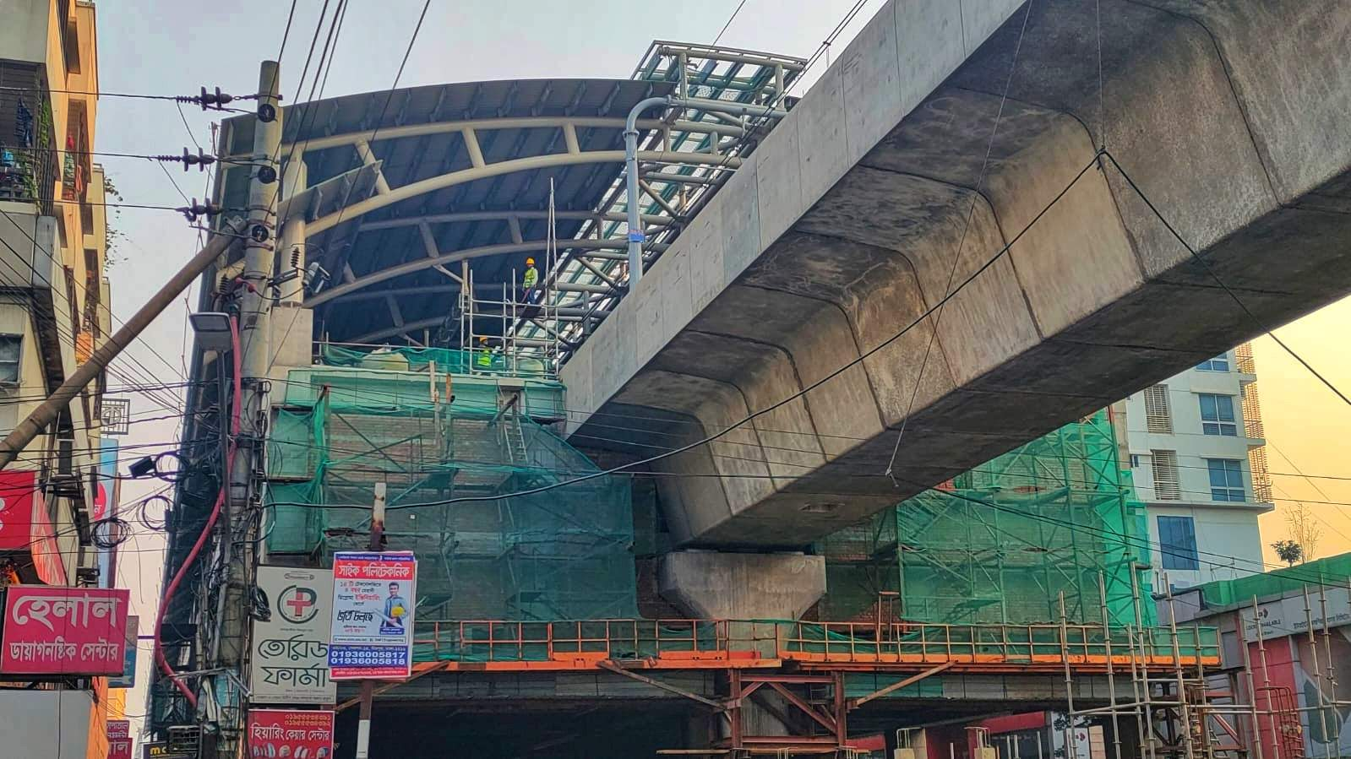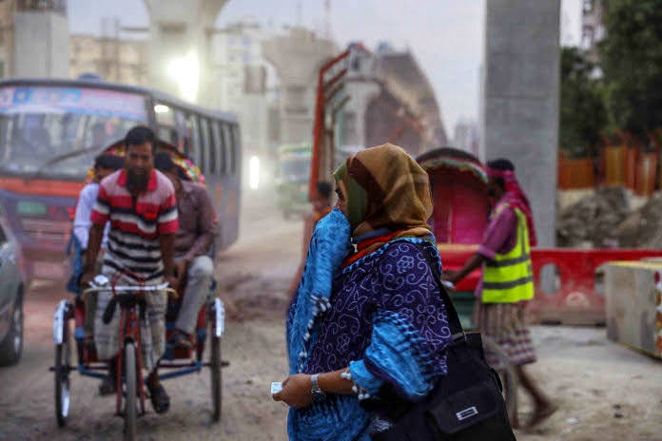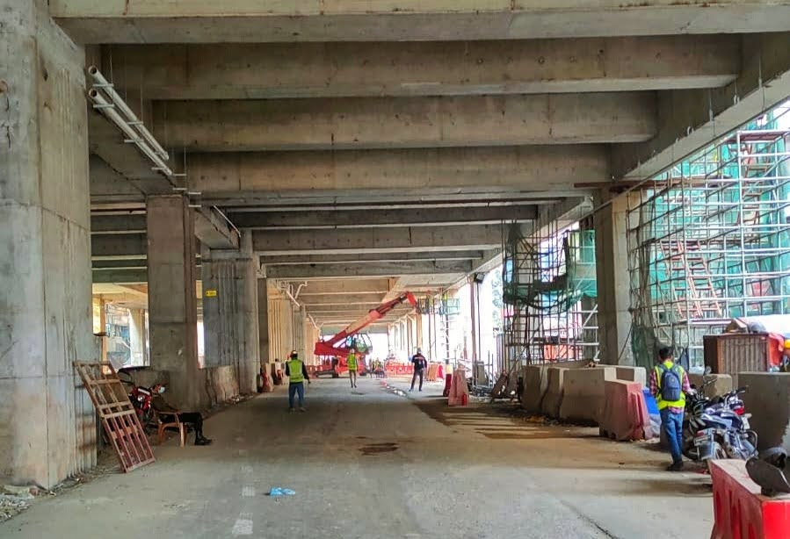

Construction of Metro Rail Station

A woman protecting herself from dust

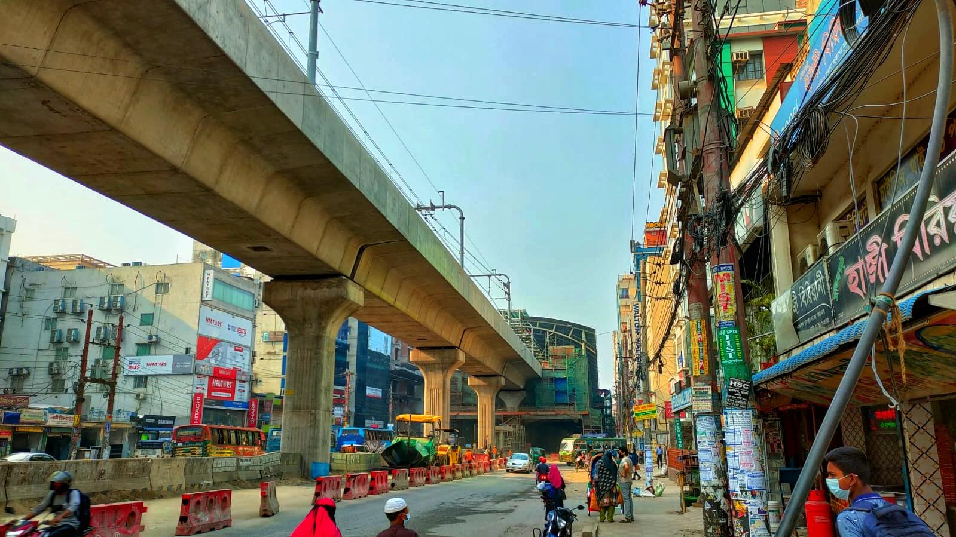

**Bibliography/ References**

Channel, J. (1994). *Vague language*. Oxford: Oxford University Press.

Halliday, M.A.K. (1993). Quantitative studies and probabilities in grammar. In Hoey, M. (Ed.) *Data, description, discourse.* London: HarperCollins, 1-25.

Hoey, M. *(1993)*.*Data, description, discourse.* London: HarperCollins, 1-25.

Lesser, R. (1979). *Linguistic investigations of aphasia.* Studies in language disability and remediation 5. London: Edward Arnold.